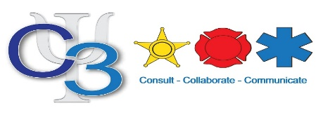

Crisis Intervention Partners
CIP
Working Together. Implementing Change.

Following the success of the Crisis Intervention Team (CIT) program which provides 40 hours of mental health training for law enforcement officers, the Crisis Intervention Partners (CIP) program provides 16 hours of training to participants with the skills to handle situations in which individuals with mental illness are in, or near, crisis. Too often, mental health crises are made worse for all parties involved due to the lack of awareness, understanding, and an appropriate response.

The mission of the Crisis Intervention Partners program is to use understanding and skills gained through specific training to identify and provide the most effective and compassionate response possible to situations involving people experiencing a mental health crisis.
Similar to CIT, the CIP program has the following outcomes:

• Crisis reduction
• Reduction of injuries to staff
• Reduction of injuries to mental health consumers
• Reduction in emergency room visits
• Decrease of involuntary treatment
• Increase in jail diversion
• Increase in community relations
This CIP training is a 2-day educational class for non-law enforcement personnel. CIP training is encouraged for anyone who works with individuals with a mental illness, i.e. social workers, teachers, emergency room staff, security personnel, correctional officers and group home staff.

- Date: December 14th and 15th, 2021 8:00 a.m. – 5:00 p.m.
- Location: Gateway Technical College- Kenosha 3520 30th Avenue, Kenosha, WI 53144 Madrigrano Conference Center Haribo Hall.
- Application Deadline: December 8th, 2021 at 1pm.
- Follow your department’s training approval process.
- Submit application at: https://forms.gle/DssNiE1ySDjT83hHA

Any questions please contact Ray Merlin at 262-564-3180 or email merlinr@gtc.edu

